**Confusion Metrics and Classification Report**

**Decision Tree:**

1. What is the overall Performance of the Decision Tree for Classification? Accuracy 🡪 88
2. What is the correct classification percentage for Non - Purchased? Recall 🡪 90
3. What is the correct classification percentage for Purchased? Recall 🡪 85
4. What is the Percentage of correct and wrong classification for Non – Purchased? Precision 🡪 92
5. What is the Percentage of correct and wrong classification for Purchased? Precision 🡪 81
6. What is the F1 Score for Non – Purchased in Classification? F1 - Score 🡪 91
7. What is the F1 Score for Purchased in Classification? F1 - Score 🡪 91
8. What is the count of true instances for Non – Purchased in the Test Dataset? Support 🡪 79
9. What is the count of true instances for Purchased in the Test Dataset? Support 🡪 41
10. What is the Total count of true instances for Purchased & Non – Purchased in the Test Dataset? Support 🡪 120
11. What is the Macro Avg of Precision? Precision 🡪 87
12. What is the Macro Avg of Recall? Recall 🡪 88
13. What is the Macro Avg of F1 Score? F1 – Score 🡪 87
14. What is the Weighted Avg of Precision? Precision 🡪 89
15. What is the Weighted Avg of Recall? Recall 🡪 88
16. What is the Weighted Avg of F1 Score? F1 – Score 🡪 88

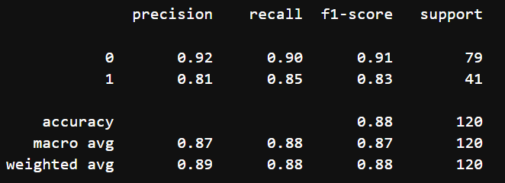

**Random Forest:**

1. What is the overall Performance of the Random Forest for Classification? Accuracy 🡪 91
2. What is the correct classification percentage for Non - Purchased? Recall 🡪 92
3. What is the correct classification percentage for Purchased? Recall 🡪 88
4. What is the Percentage of correct and wrong classification for Non – Purchased? Precision 🡪 94
5. What is the Percentage of correct and wrong classification for Purchased? Precision 🡪 86
6. What is the F1 Score for Non – Purchased in Classification? F1 - Score 🡪 93
7. What is the F1 Score for Purchased in Classification? F1 - Score 🡪 87
8. What is the count of true instances for Non – Purchased in the Test Dataset? Support 🡪 79
9. What is the count of true instances for Purchased in the Test Dataset? Support 🡪 41
10. What is the Total count of true instances for Purchased & Non – Purchased in the Test Dataset? Support 🡪 120
11. What is the Macro Avg of Precision? Precision 🡪 90
12. What is the Macro Avg of Recall? Recall 🡪 90
13. What is the Macro Avg of F1 Score? F1 – Score 🡪 90
14. What is the Weighted Avg of Precision? Precision 🡪 91
15. What is the Weighted Avg of Recall? Recall 🡪 91
16. What is the Weighted Avg of F1 Score? F1 – Score 🡪 91

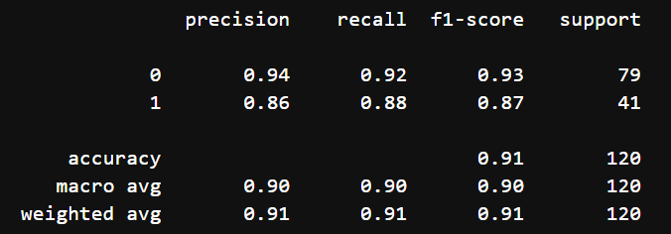

**­­­­**

**­Support Vector Classifier:**

1. What is the overall Performance of the SVC for Classification? Accuracy 🡪 79
2. What is the correct classification percentage for Non - Purchased? Recall 🡪 97
3. What is the correct classification percentage for Purchased? Recall 🡪 44
4. What is the Percentage of correct and wrong classification for Non – Purchased? Precision 🡪 77
5. What is the Percentage of correct and wrong classification for Purchased? Precision 🡪 90
6. What is the F1 Score for Non – Purchased in Classification? F1 - Score 🡪 86
7. What is the F1 Score for Purchased in Classification? F1 - Score 🡪 59
8. What is the count of true instances for Non – Purchased in the Test Dataset? Support 🡪 79
9. What is the count of true instances for Purchased in the Test Dataset? Support 🡪 41
10. What is the Total count of true instances for Purchased & Non – Purchased in the Test Dataset? Support 🡪 120
11. What is the Macro Avg of Precision? Precision 🡪 83
12. What is the Macro Avg of Recall? Recall 🡪 71
13. What is the Macro Avg of F1 Score? F1 – Score 🡪 73
14. What is the Weighted Avg of Precision? Precision 🡪 81
15. What is the Weighted Avg of Recall? Recall 🡪 79
16. What is the Weighted Avg of F1 Score? F1 – Score 🡪 77

